Ansible Task -03

Task Title
Write a single ansible playbook which will install Apache and nginx. Note: Playbook should not be hardcoded and pass the variables from different file.
Objective
To create and execute a single Ansible playbook that installs Apache and Nginx on target servers without hardcoding values, by passing package names and configuration values from an external variables file.
Prerequisites
- Linux servers (Debian/Ubuntu based)
- Ansible installed on control node
- SSH access to target nodes
- Inventory file configured
- Root or sudo privileges on target machines
Steps Performed:
Step 1: Created a Variable File (vars.yml)
- Defined all configurable values in a separate file to avoid hardcoding.
- Stored web server package names and Nginx port number.
Variables defined:
- web_servers → apache2, nginx
- nginx_port → 81
This ensures reusability and flexibility.
Step 2: Created a Single Ansible Playbook
- Created apache_nginx_server.yml.
- Enabled privilege escalation using become: yes.
- Included the variable file using vars_files.
Step 3: Updated Package Cache
- Used the apt module to update the cache.
- Applied condition to run only on Debian-based systems.
Step 4: Installed Apache and Nginx
- Used the package module.
- Installed packages dynamically using the web_servers variable.
- Ensured both services were installed in one task.
Step 5: Resolved Port Conflict
- Modified Nginx configuration to run on port 81 instead of 80.
- Updated both:
  - IPv4 listen directive
  - IPv6 listen directive
- Used the replace module to update the configuration file.
Step 6: Tested Nginx Configuration
- Executed nginx -t command.
- Ensured configuration validity before restarting the service.
- Prevented failure if configuration was incorrect.
Step 7: Restarted and Enabled Services
- Restarted Nginx to apply port changes.
- Started and enabled Apache service.
- Ensured Nginx service is running and enabled at boot.
Step 8: Executed the Playbook
- Performed syntax validation using:
- ansible-playbook apache_nginx_server.yml --syntax-check
- Executed the playbook successfully:
- ansible-playbook apache_nginx_server.yml
Step 9: Verification
- Verified Apache running on port 80 via browser.
- Verified Nginx running on port 81 via browser.
- Play recap showed no failures.
Validation Steps
- Access Apache:
- http://<server-ip>
- Access Nginx:
- http://<server-ip>:81
- Confirm services:
- systemctl status apache2
systemctl status nginx
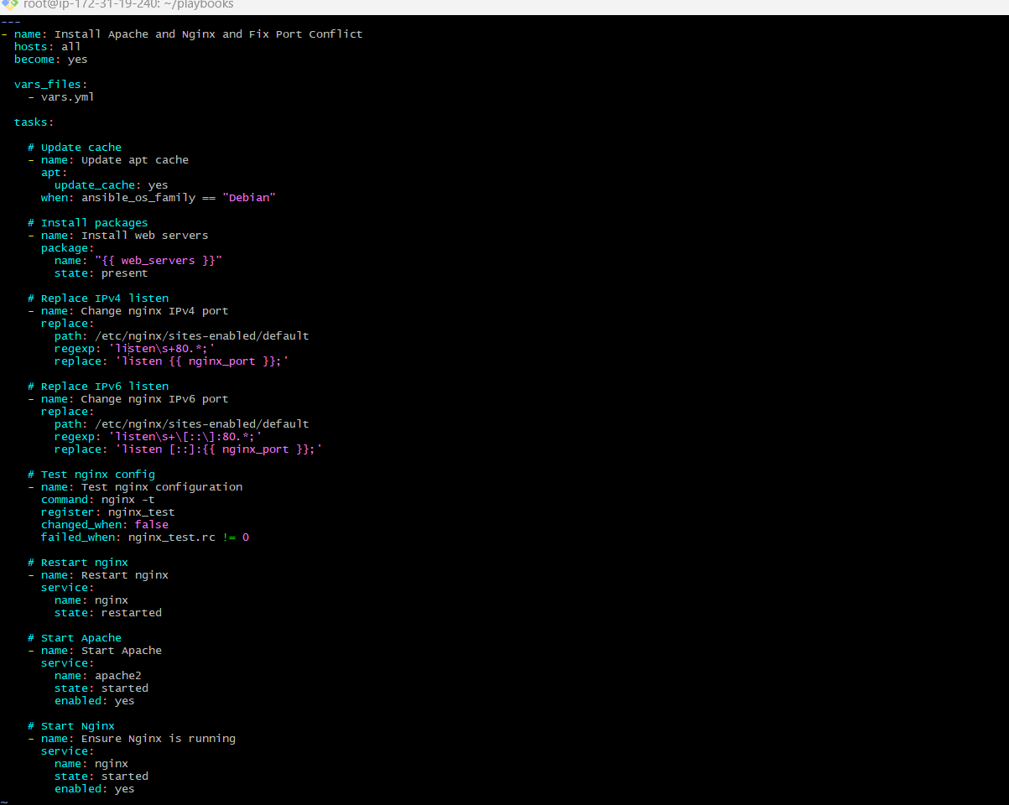
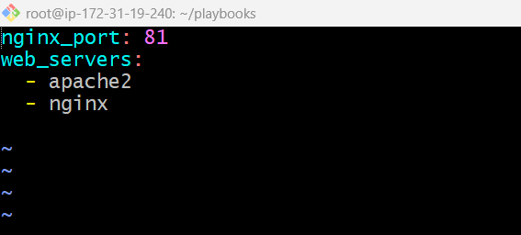
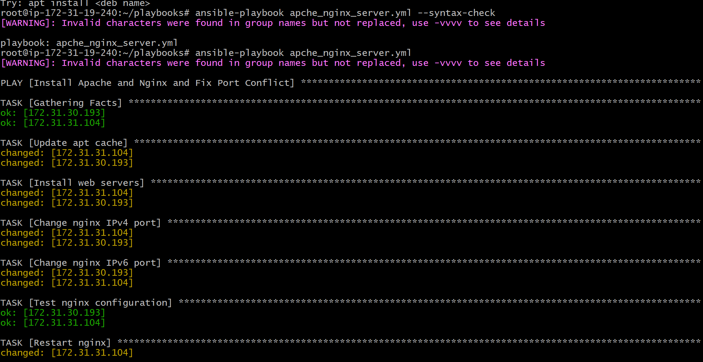
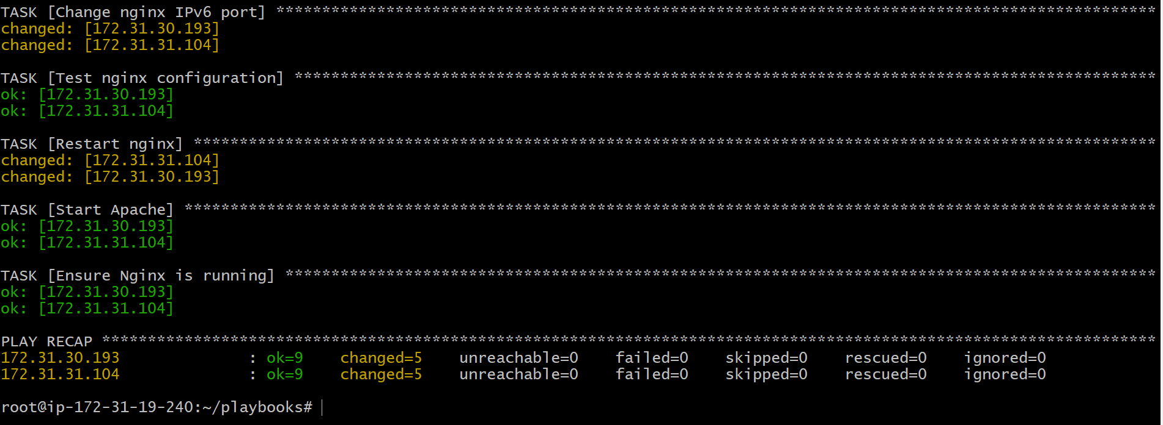
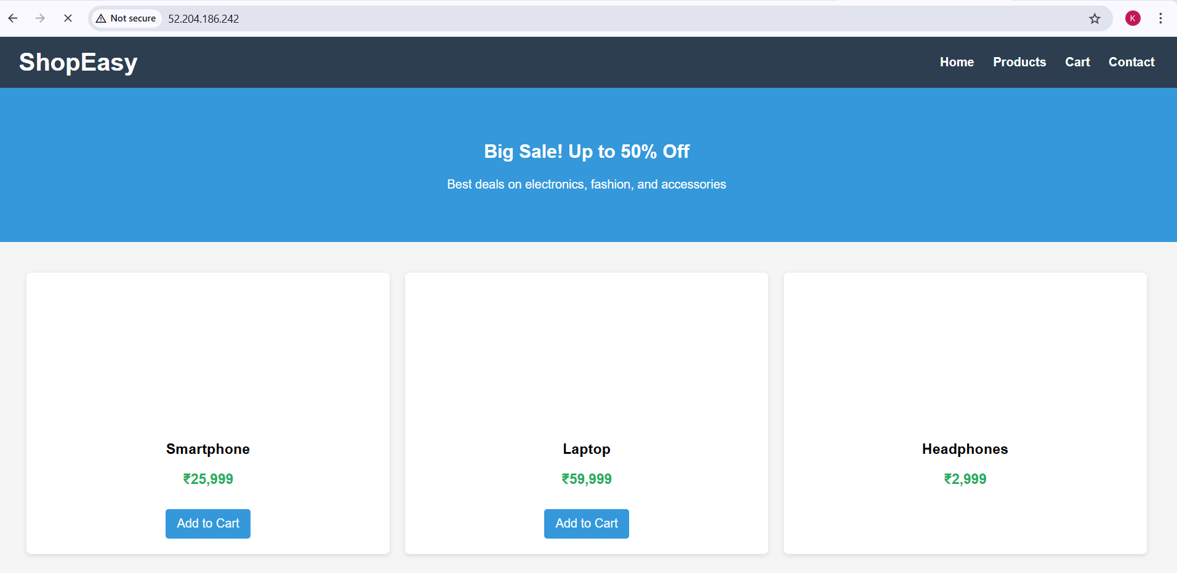

Issues Faced
- Initial command typo (ansible-playbooks instead of ansible-playbook)
- Resolved by using the correct Ansible command.
Conclusion
Successfully implemented a single, reusable Ansible playbook to install Apache and Nginx using external variables, avoiding hardcoding. Port conflict was resolved by running Nginx on port 81, and both services were verified to be running correctly.

Task Title
Ansible playbook to create 10 different directories with minimal code and directory names should be passed as variables.
Objective
To create 10 different directories on multiple target nodes using a single Ansible playbook, with directory paths passed through a variable file, keeping the playbook minimal and reusable.
Prerequisites
- Ansible installed on control node
- Inventory configured with target hosts
- SSH connectivity to managed nodes
- Root/sudo access (become: yes)
- Linux target systems
Steps Performed:
Step 1: Created Variable File (vars.yml)
- Defined directory paths as a list variable.
- Avoided hardcoding paths in the playbook.
Directories defined:
- /opt/dir1 to /opt/dir10
Step 2: Created a Single Ansible Playbook
- Created create_multiple_dir.yml.
- Enabled privilege escalation using become: yes.
- Included variables using vars_files.
Step 3: Used Minimal Code with Loop
- Used the file module to create directories.
- Used a single task with a loop to iterate over directory list.
- Set directory permissions using mode: 0755.
Step 4: Executed the Playbook
- Ran the playbook using:
- ansible-playbook create_multiple_dir.yml
- Play executed successfully on all target nodes.
- No failures or unreachable hosts reported.
Step 5: Verified Directory Creation
- Logged into each target node.
- Navigated to /opt directory.
- Verified all 10 directories were created:
  - dir1 through dir10
- Confirmed correct permissions and ownership.
Validation Steps
On each managed node:
cd /opt
ls
ll
All directories were present on:
- Ansible-Worker-01
- Ansible-Worker-02
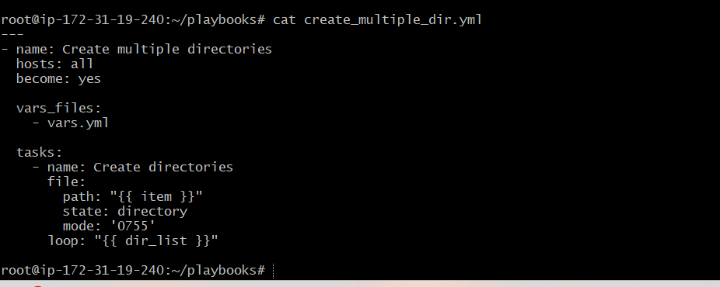
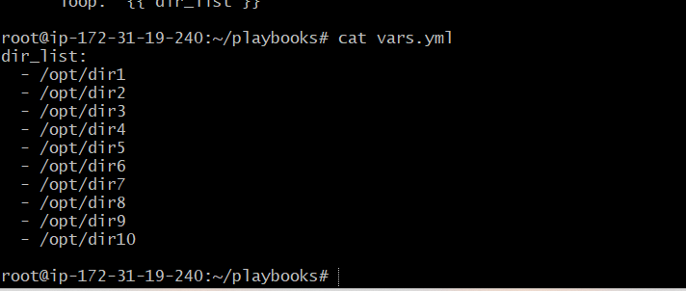
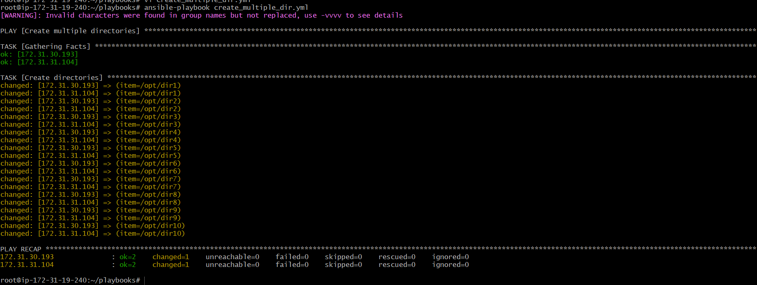
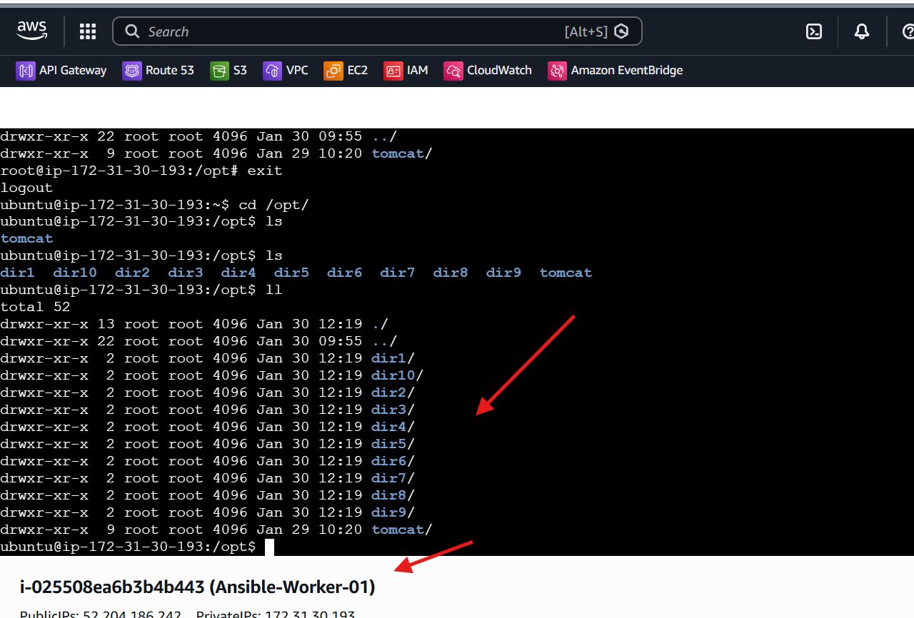
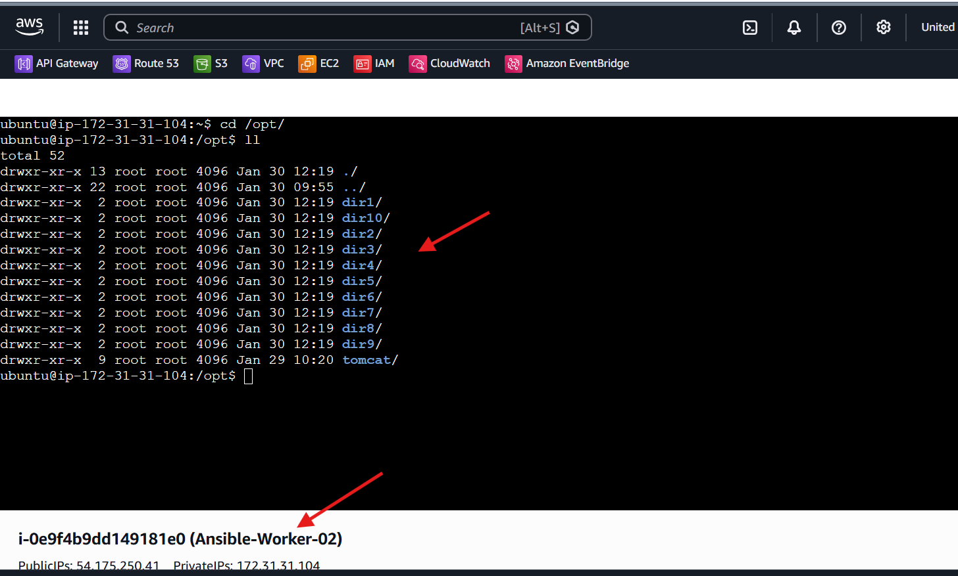
Issues Faced:
- No functional issues encountered.
- Warning related to invalid characters in group names was informational and did not affect execution.
Conclusion:
Successfully created 10 different directories using a single Ansible playbook with directory names passed as variables. The solution is minimal, idempotent, and scalable, and it executed successfully across multiple nodes.

Task Title
Ansible Playbook to Copy SSH Key from Master to Worker Nodes (Passwordless Authentication)
Objective
To provision a master and worker setup where a common user (ansadm) is created on all nodes, SSH keys are generated on the master node, and passwordless SSH access is enabled from the master to all worker nodes using Ansible.
Prerequisites
- Ansible installed on control node
- AWS EC2 instances provisioned (1 Master, 2 Workers)
- Inventory file configured with master and workers groups
- SSH access to EC2 instances using a PEM key (sshless.pem)
- Ubuntu OS on all nodes
Steps Performed:
Step 1: Provisioned EC2 Instances
- Launched three EC2 instances from the AWS EC2 console.
- Assigned instance roles as:
  - 1 Master node
  - 2 Worker nodes
- Used Ubuntu AMI and t3.micro instance type.
- Verified all instances were in Running state with 3/3 status checks passed.
- Confirmed instance naming:
  - master
  - worker-01
  - worker-02
Step 2: Configured Ansible Inventory
- Updated /etc/ansible/hosts file.
- Added IP address of master under master group.
- Added IP addresses of worker nodes under workers group.
- Ensured inventory groups matched playbook host definitions.
Step 3: Created Common User on All Nodes
- Created an Ansible playbook to create a common user ansadm.
- Assigned /bin/bash as default shell.
- Added user to sudo group.
- Enabled passwordless sudo using /etc/sudoers.d/ansadm.
- Executed playbook on all nodes using Ansible.
Step 4: Verified User Creation
- Logged into each instance.
- Verified ansadm user exists.
- Confirmed passwordless sudo access using:
- sudo su - ansadm
Step 5: Generated SSH Key on Master Node
- Created a dedicated Ansible playbook for SSH key setup.
- On the master node:
  - Created /home/ansadm/.ssh directory.
  - Set correct ownership and permissions.
  - Generated SSH key pair (id_rsa and id_rsa.pub) as ansadm.
Step 6: Read Master Public Key
- Used Ansible slurp module to read the master’s public key.
- Stored the key content in a registered variable.
Step 7: Copied SSH Key to Worker Nodes
- Added the master’s public key to authorized_keys on all worker nodes.
- Used authorized_key module.
- Ensured correct decoding using b64decode.
- Maintained proper ownership and permissions.
Step 8: Executed SSH Key Distribution Playbook
- Ran the SSH key playbook using Ansible.
- Verified successful execution on both master and worker nodes.
Step 9: Verified Passwordless SSH Authentication
- Logged into the master node as ansadm.
- Initiated SSH connection to worker nodes:
- ssh ansadm@<worker-ip>
- Confirmed login without password prompt.
Validation Steps
- ansadm user exists on all nodes
- Passwordless sudo works for ansadm
- SSH key exists on master
- Public key present in worker authorized_keys
- SSH from master → workers works without password
a) Provision new 3 ec2 machines, one master and two worker nodes.
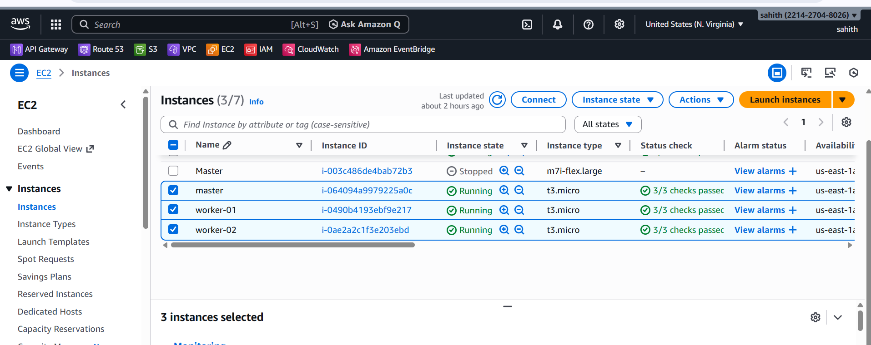




b) Create common user called ansadm and provide Sudo priviliges on 3 ec2 instances.
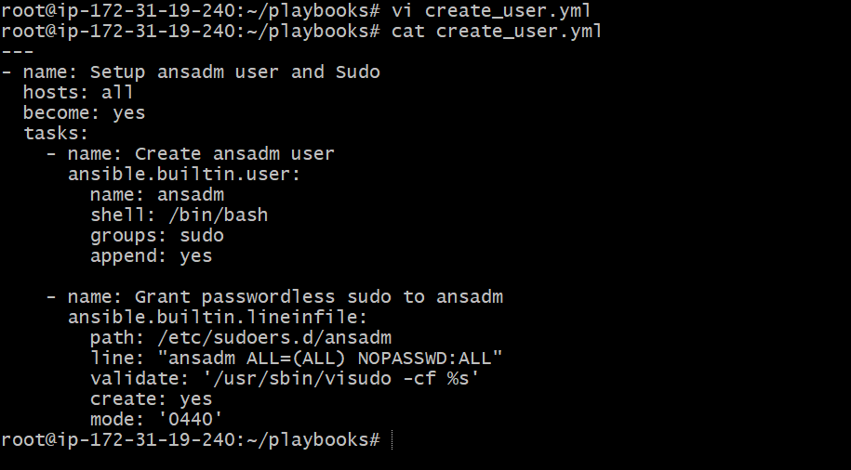
. c)Create ssh-keygen in master and your playbook should copy the keygen making it password less authentication.
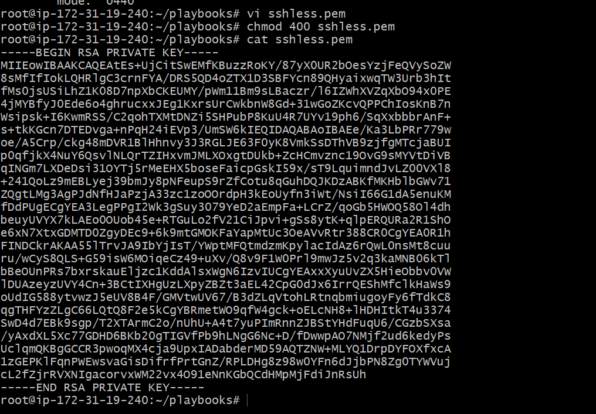
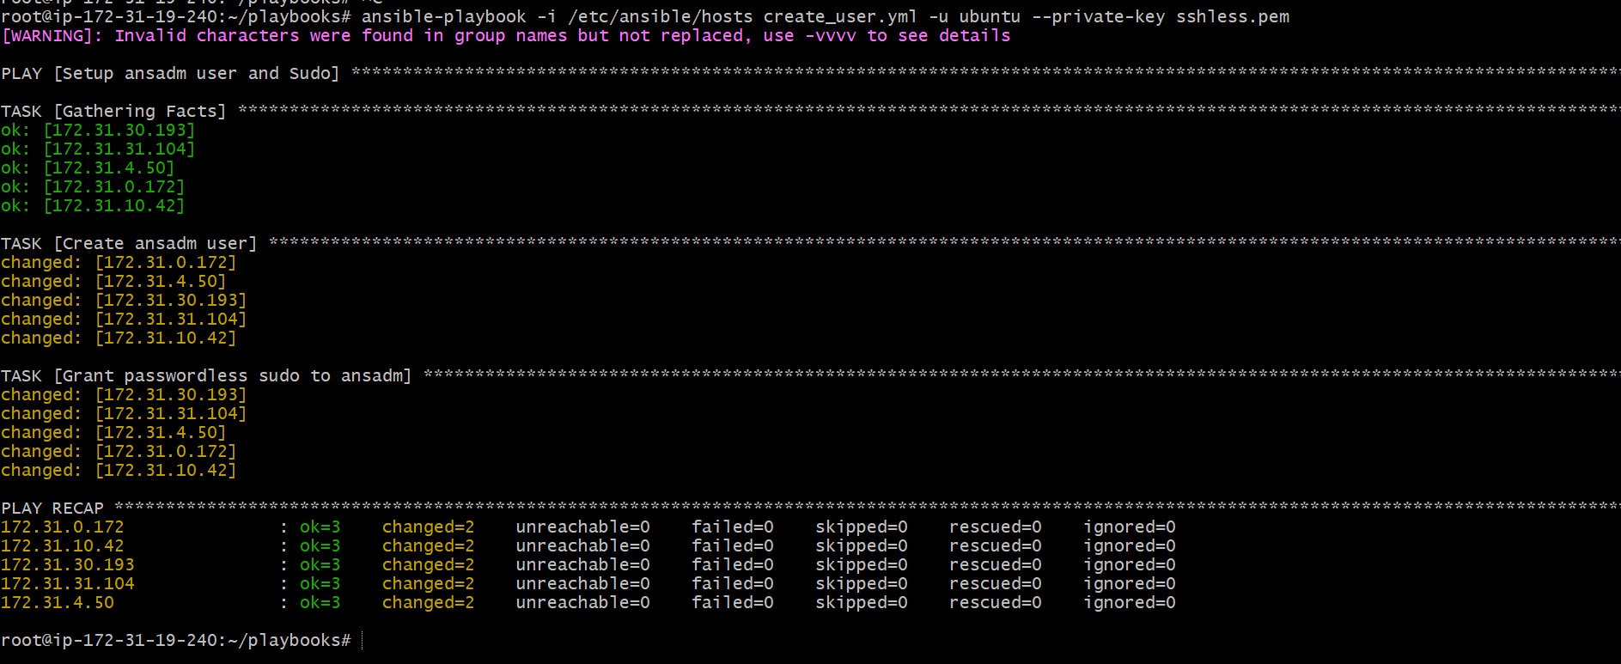

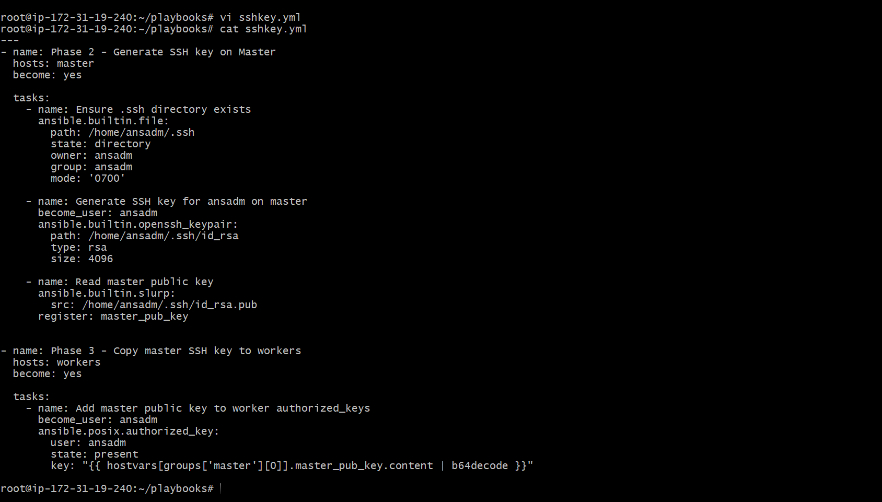

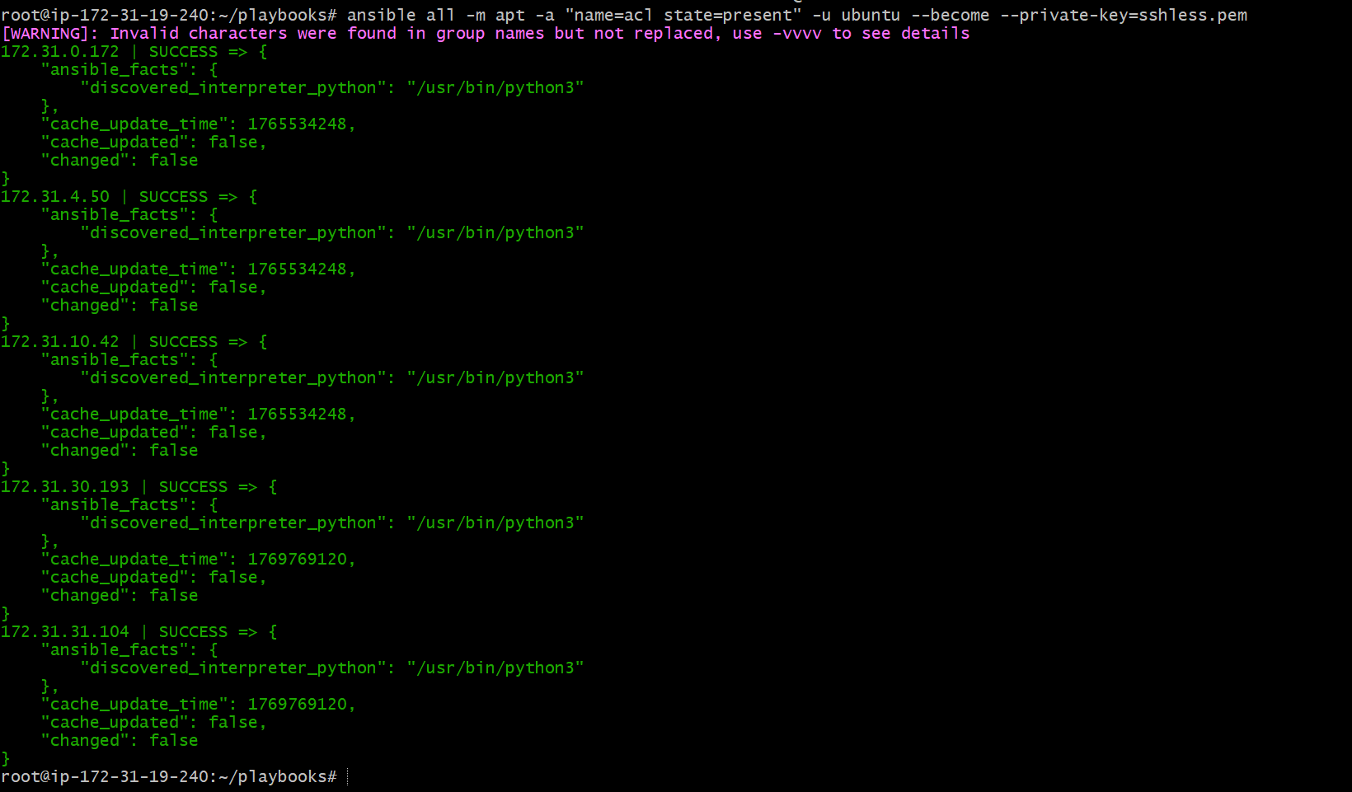
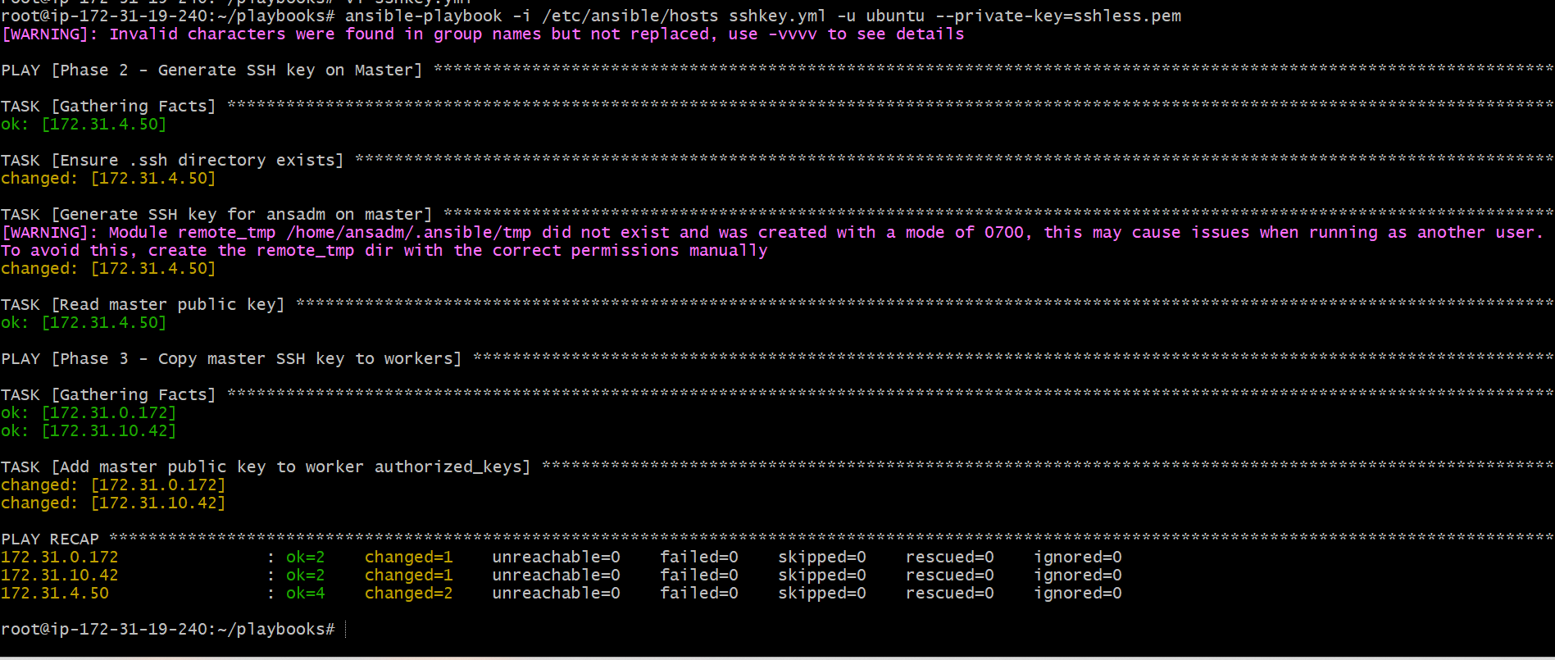
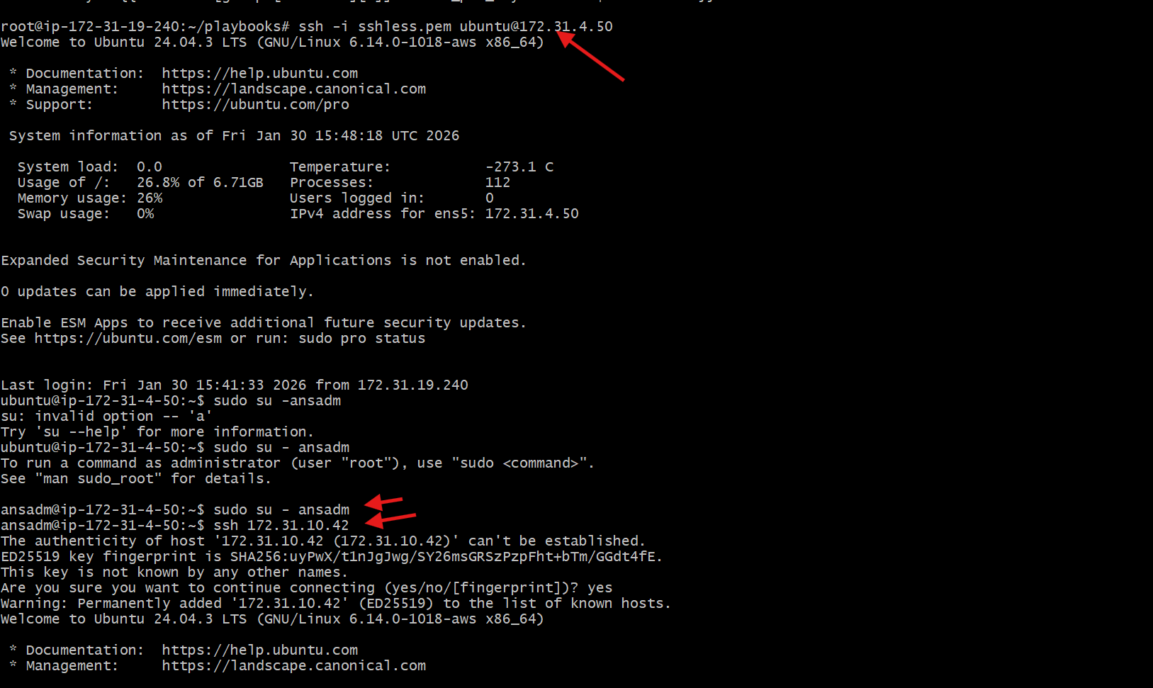
Issues Faced
- YAML indentation and multi-play structure issues in initial SSH playbook
- Incorrect SSH verification attempts using ubuntu instead of ansadm
- Minor command syntax errors (dash vs hyphen)
- All issues resolved through correction and re-validation
Conclusion
Successfully implemented passwordless SSH authentication from master to worker nodes using Ansible. A common user with sudo privileges was created across all EC2 instances, SSH keys were generated on the master, and public keys were securely distributed to worker nodes, enabling seamless, passwordless access.

Task Title
Ansible Playbook to Inject Ansible Vault Variables
Objective
To securely store sensitive variables using Ansible Vault and inject those encrypted variables into an Ansible playbook at runtime.
Prerequisites
- Ansible installed on control node
- Access to target hosts
- Basic knowledge of YAML
- Vault password available
- Inventory file configured
Steps Performed:
Step 1: Created a Plain Variables File
- Created a file named password.yml.
- Added sensitive variables in plain text for initial setup.
Variables added:
- db_user
- db_password
Step 2: Encrypted the Variables File Using Ansible Vault
- Used Ansible Vault to encrypt password.yml.
- Set and confirmed a vault password during encryption.
Command used:
ansible-vault encrypt password.yml
Step 3: Verified Vault Encryption
- Displayed the encrypted file to confirm it is no longer readable.
- Used Ansible Vault view command to verify encrypted content.
Commands used:
cat password.yml
ansible-vault view password.yml
Step 4: Created Ansible Playbook to Inject Vault Variables
- Created playbook use_vault.yml.
- Included encrypted variables file using vars_files.
- Used the variables inside a task to confirm injection.
Step 5: Executed the Playbook with Vault Password
- Ran the playbook and provided vault password at runtime.
- Ansible successfully decrypted the variables.
Command used:
ansible-playbook use_vault.yml --ask-vault-pass
Step 6: Verified Output
- Playbook executed successfully on all target nodes.
- Vault variables were correctly injected and accessed.
- No failures reported in play recap.
Validation Steps
- Vault variables displayed correctly in output.
- Play recap showed:
  - failed=0
  - unreachable=0
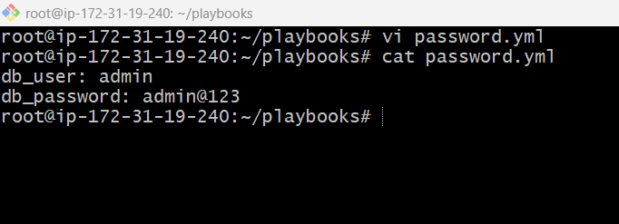
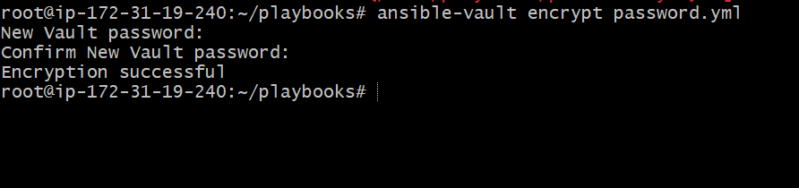
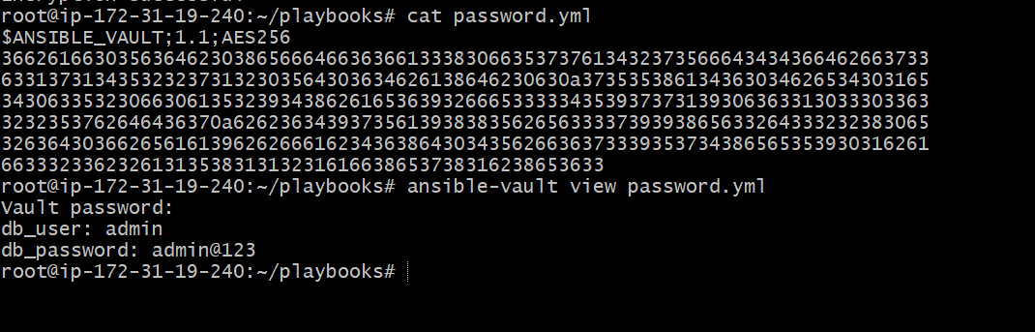
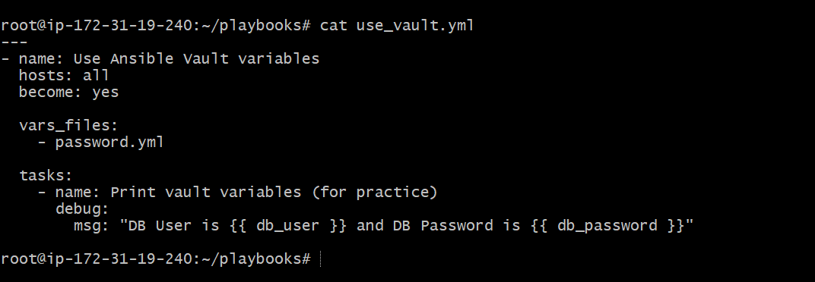
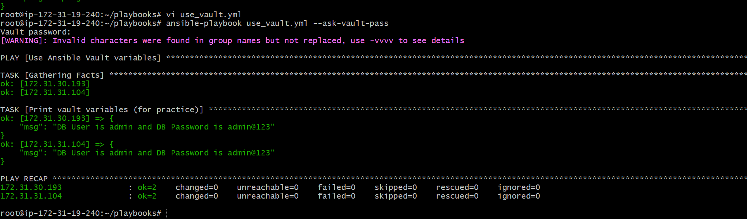

Issues Faced:
- Initial variable undefined issue due to incorrect vault file reference.
- Resolved by ensuring correct encrypted file name (password.yml) in vars_files.

Conclusion:
Successfully encrypted sensitive variables using Ansible Vault and injected them into an Ansible playbook at runtime. This approach ensures secure handling of secrets while maintaining playbook flexibility and security best practices.

